Introduction to Blockchain and Its Applications
Term Project 2 – smart contract
(April 23, 2024)

Environment:
Remix IDE
Solidity ^ 0.8.19
Compiler 0.8.19+commit.7dd6d404

Requirement:
- (25%) Create your own token and transfer 100 tokens to TA (0xF327C323A6E6eAf85063f4E60a366Cd21EFB89A5).
2 Screenshots are necessary before and after you successfully transfer 100 tokens to TA.
e.g.
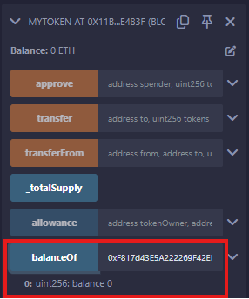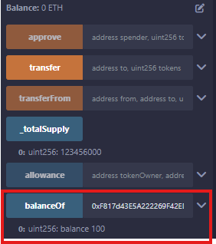

- (35%) Write a function similar to the faucet, and you can add some variables for it. One screenshot is needed after the user using “faucet” function, and call “balanceOf” function.
- The person (address) who established the contract acts as a faucet and is responsible for distributing tokens to other requesters, but can no longer take tokens from himself/herself.
- Others (other addresses) can call the function to claim 500 tokens at a time, and the same address can only claim once within 30 seconds.
Hint: You should create a function named “faucet”. Then, use the concepts of “require” and “block.timestamp” to implement it.

- (40%) Complete a simple lottery game, including the following functions. Five screenshots(similar with e.g.) and function explanations(just for part B,C) are needed.
- random
- Take “block.timestamp”, “block.difficulty” and “msg.sender” as input. After hashing with SHA3-256, an unsigned integer is obtained as a random number.
You can directly use the following function.
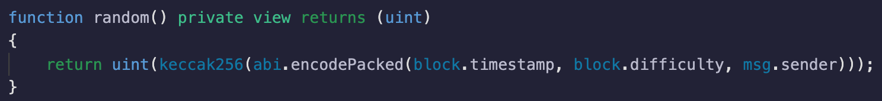

e.g.
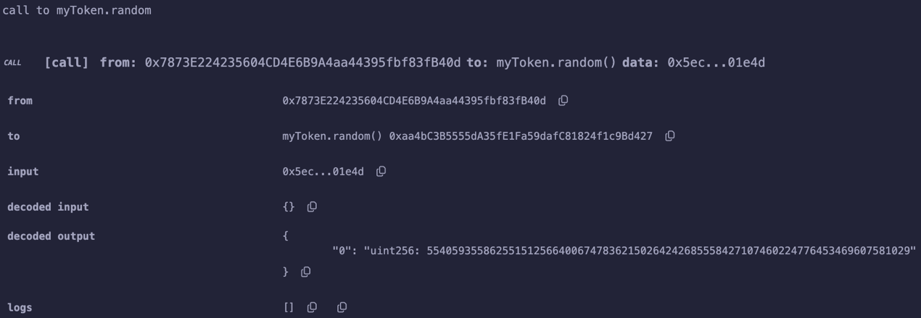

- betLottery
- The person (address) who established the contract acts as the banker, and cannot participate in the bet lottery.
- Others (other addresses) can call the function to spend a fixed amount of 100 tokens to buy a lottery ticket. Of course, players can also buy multiple times to increase the winning rate.

e.g.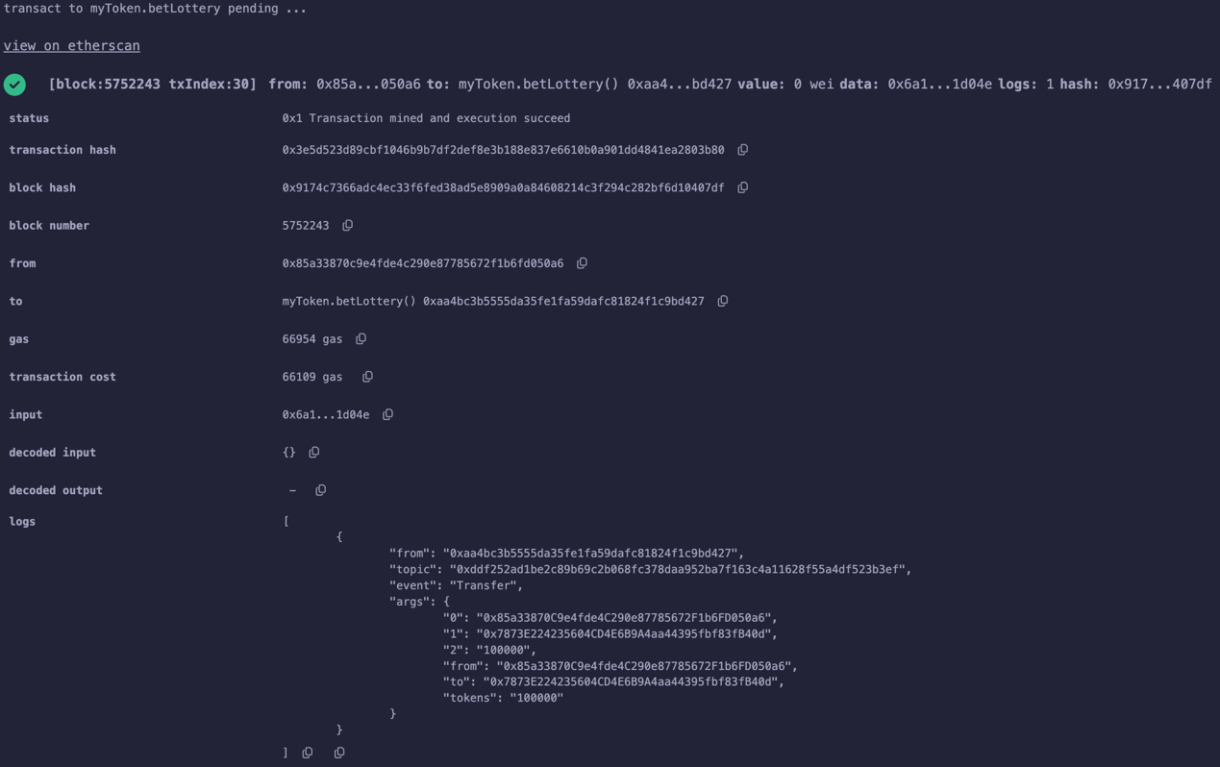

- Draw
- Only the banker can call the Draw function to randomly select one lottery ticket buyer as the lottery winner. The winner can get 90% of the ticket revenue as a bonus.
For instance, suppose a total number of 8 tickets were sold. Therefore, the winner can get 720 tokens from the banker.
- After the draw, the banker can’t call the function again within 2 mins.
- At least one lottery ticket must be sold. Otherwise, the function can’t be executed.

e.g.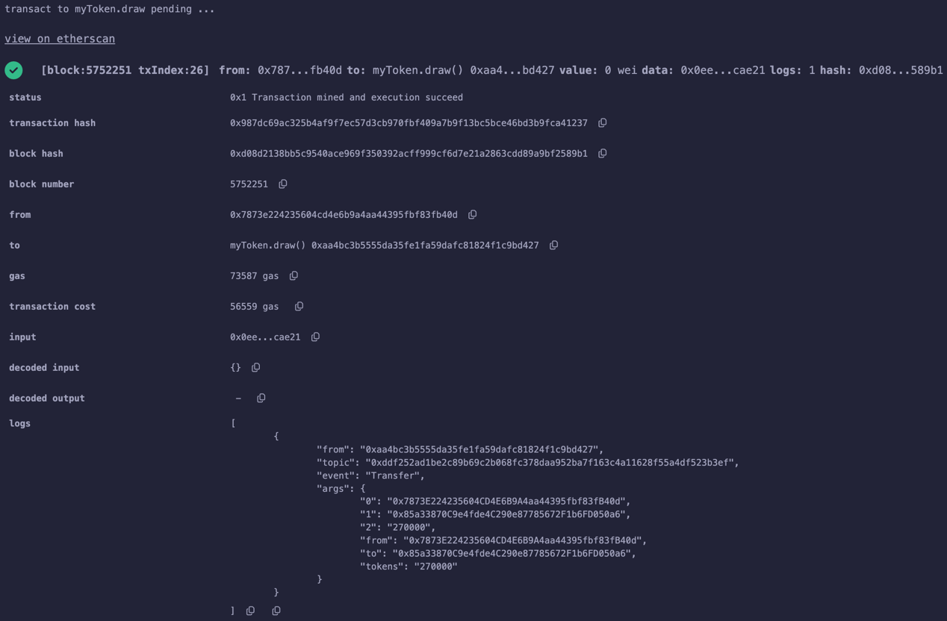

- getAllPlayers
- Everyone can call the getAllPlayers function to see the addresses of all lottery ticket buyers.

e.g.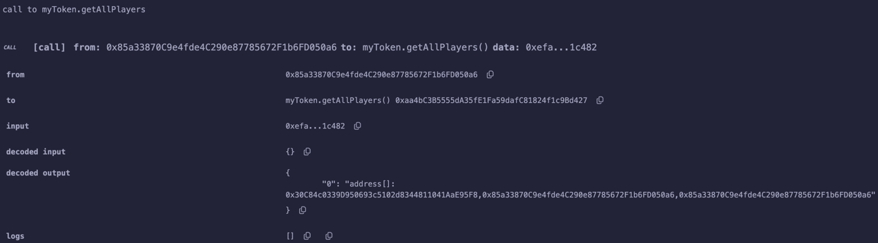

- Winner(just variable, not function)
- Using a variable to store the winner’s address so that everyone can see the winner of the lottery game.

e.g. 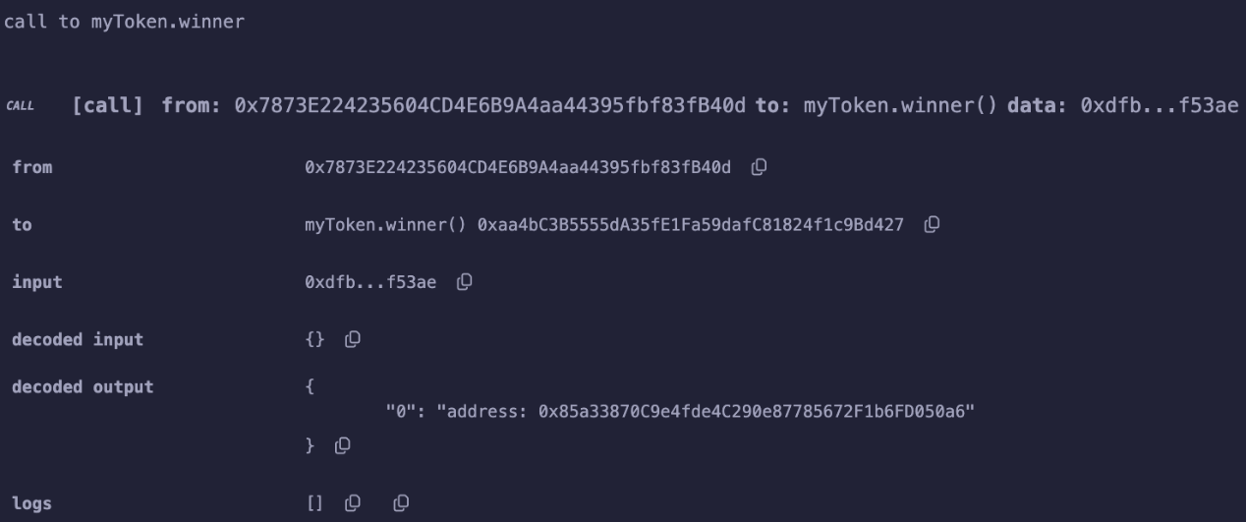

- Bonus1 (10 %):目前的樂透遊戲中，玩家透過購買彩卷即可參加抽獎，請將抽獎遊戲的參加規則更改為請玩家在1~46的號碼中挑選不重複的三個數字，每次開獎由遊戲維護方同樣自1~46的號碼中雖機挑選不重複的三個數字。完全猜中三個數字的節點為贏家，若贏家不只一位則由所有贏家平分獎勵。若沒有贏家則將獎池累計到下一輪。
遊戲玩家每次花費100個代幣購買彩卷，有90個代幣放入獎池、10個代幣則做為手續費轉給遊戲維護方。

Hand in:
Please package all the screenshot and function explanation into a PDF file. And upload the “studentID_HW2.zip” file to the Moodle system before 5/12 23:59, including PDF file and .sol file.

